- SENTIMENT ANALYSIS

- “What is Sentiment Analysis ?”
Sounds a little bit technical term, so before jumping into the topic, we should first understand its literal meaning …. .so the word sentiment means- a view or opinion that is expressed and analysis means- detailed examination of the elements or structure of something.

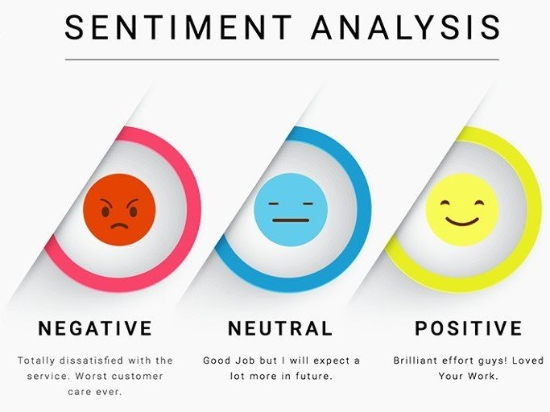
So, the definition will be sentiment analysis is “the process of computationally identifying and categorizing opinions expressed in a piece of text, especially in order to determine whether the writer’s attitude towards a particular topic, product etc. is positive, negative or neutral.”

Fig.1 sentiment and analysis

For better understanding let’s take an example –
Like you all know that success of a company or a product directly depends on its customer, right ?? so if the customer likes your product , it’s your success , just celebrate it but with obeying corona protocols and if in case they don’t like then you certainly need to improvise on it by making some changes in it .
So, how will you know whether your product is successful or not . well for that you need to analysis your customer and the attitude of analysing your costumer is to analysis the sentiment or opinion of them and this is where the sentiment analysis came into picture .
Now , see whenever you buy any product you would like to look at the feed back of other peoples , particularly about the product whether it is good or bad or while watching any video or listening any song on youtube sometimes we are interested to know about the sentiments of different people about that video or song by reading the comments mention below the video, well we do that manually .


Fig. 2

Now just consider at the company level so how will the company analysis , what the customer are thinking about their product .they don’t have just one or two customer . they cannot go home of each and every customer or just scroll down reading millions of reviews about their product and spend years and years . right ?? they have more than millions of customer , so what they will do , so this is where the company needs to perform the sentiment analysis . to know whether the product is doing actually good in the market or not .

Fig. 3
2. “ HOW TO PERFORM SENTIMENT ANALYSIS ”
So, now as we are introduced by the sentiment analysis, let’s know that how does it work:-
Let’s take a sentence – “The movie was great!” ……so the very first step is the step of “TOKENIZATION” which simply means to dividing your paragraph into different set of statements or dividing your statement into set of words. so the statement “The movie was great!” will now divided into separate set of words :- that is as follows
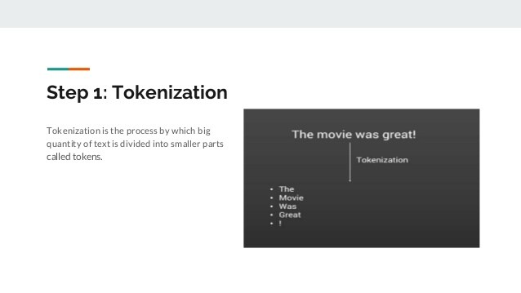
              - The
              - Movie
              - Was
              - Great
              - !

Fig. 4

Second step is “Cleaning the data” so cleaning the data means to remove all the special character or any other word which do not add any value to the analytics part , so we do not need that exclamatory mark on the sentence now , so therefore now we remain with 4 words .
    - The
    - Movie
    - Was
    - Great
Next step is “Removing the stop words” as before. We do not need any word which do not add any value to the analytics part, so the stop words like – the, was, it, he, she, her, etc. do not add much value to analytics part, so we can easily remove them. Now , we are left with just two words:-
Movie
Great

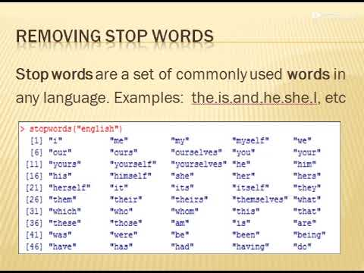

Fig.5
Now, step 4 is the “Classification” step, now as we are left with just two words, so now our next duty is to classify the words as neutral, positive and negative. If the word will be positive we give it a sentiment score which is +1, for negative it’s a -1 and for neutral it is 0. Now here is the pat where machine learning come, you can model your data with a bag of words or you can use lexicons which is nothing but the dictionary of pretty classified set of words. Now, when the model is done, you can perform the test on the analysis statement and more the accuracy score, better will be the classification.

Now the 5th step is to “CALCULATION” and to calculate the final scores of the sentiment, so now as we have just two words here which add to the value to the analytics part. So, on combining the statement we can say that we have 1 and 0 which is equal to 1. So you can say that since the answer is 1 is greater than 0, the statement is positive.

3.“PROS AND CONS OF USING SENTIMENT ANALYSIS”
Advantages :-
By using sentiment analysis, you gauge how customers feel about different areas of your business without having to read thousands of customer comments at once.

If you have thousands of feedback per month, it is impossible for one person to read all of these responses. By using sentiment analysis and automating this process, you can easily drill down into different customer segments of your business and get a better understanding of sentiments in these segments.
Fig. 6
Disadvantages:-
While sentiment analysis is useful, it is not a complete replacement for reading survey responses. Often, there are useful nuances in the comments themselves. Where sentiment analysis can help you further is by identifying which of these comments you should read.

4. “THE TECHNOLOGY USING FOR IMPLEMENTING SENTIMENT ANALYSIS”
A sentiment analysis system for text analysis combines natural language processing
(NLP) and machine learning techniques to assign weighted sentiment scores to the entities, topics, themes, and categories within a sentence or a phrase.
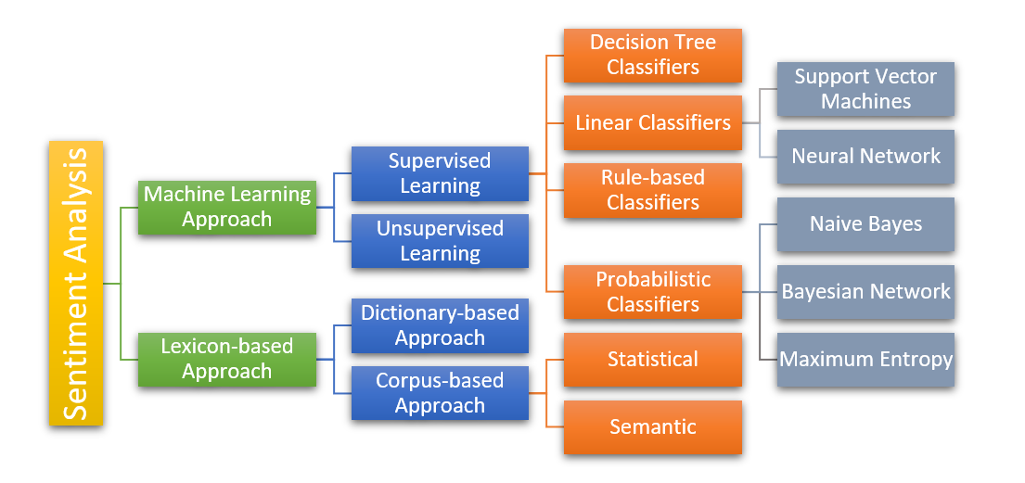
Fig.7
5. “SENTIMENT ANALYSIS IN FUTURE”
Sentiment analysis has been an important tool for brands looking to learn more about how their customers are thinking and feeling. It is a relatively simplistic form of analytics that helps brands find key areas of weakness (negative sentiment) and strengths (positive sentiments).
The future of sentiment analysis is going to continue to dig deeper, far past the surface of the number of likes, comments and shares, and aim to reach, and truly understand, the significance of social media interaction and what they tell us about the customers behind the screens .
6. Summary and Future Work
- Sentiment Analysis is a set of tools to identify and extract opinions and use them for the benefit of the business operation Such algorithms dig deep into the text and find the stuff that points out the attitude towards the product in general or its specific element.
Sentiment analysis is a uniquely powerful tool for business that are looking to measure attitudes, feeling and emotions regarding their brands. To date, the majority of sentiment analysis projects have been conducted almost exclusively by companies and brands through the use of social media, survey responses and other hubs of user-generated content . the future of sentiment analysis is going to deeper, far past the surface of the number of likes, comments and shares, and aim to reach, and truly understand, the significance of social media interaction and what they tell us about the consumers behind the screen.

References

Help from internet and from different websites ………. Specifically from google and you tube, following are some website:-
- Wikipedia
- Scholar.google.com
- Lui cited by 2524
- From edureka ( a you tube channel )
- Brand24.com


THANK YOU

